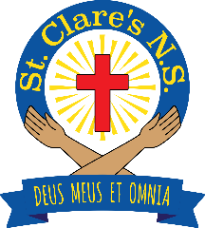

St. Clare's N.S.
• BALLYJAMESDUFF, CO. CAVAN •

Principal: Mr. Karl Mc Cartin Tel. (049) 854 4908
Deputy Principal: Ms. Sandra Murphy Web: www.scnsbjd.com
Roll No.: 19983B Email: stclaresbjdns@gmail.com

School Calendar 2025/26

School reopens on Wednesday, 27th August 2025

Halloween Break
School closes on Friday 24th October, 2025
Reopens on Monday 3rd November, 2025

Christmas Holidays
School closes on Friday, 19th December 2025 (Half Day)
Reopens on Monday 5th January 2026

St. Brigid’s Day
School closed Monday 2nd February 2026

Mid-Term Break
School closed on Thursday 19th & Friday 20th February 2026

St. Patrick’s Day
School closed Tuesday 17th March 2026

Easter Holidays
School closes on Friday 27th March 2026 (Half Day)
Reopens on Monday 13th April 2026

School Closed for Public Holidays:
Monday 4th May 2026 (Public Holiday)
Monday 1st June 2026 (Public Holiday)

Summer Holidays:
School closes on Friday 19th June 2026 (Half Day)

This calendar conforms with the standardised school year as laid down by the Minister for Education & Youth. As per guidelines, changes may be required to make up for time lost due to unforeseen school closures during the year.

